**Local Area Network (LAN)**

LAN is a group of network devices that allow communication between connected devices. The private ownership has control over the local area network rather than the public. LAN has a shorter propagation delay than MAN as well as WAN. It covers the smallest area such as College, School Hospital and so on.

**Uses of LAN**

LAN is ideal when:

* All the devices are located nearby, for example in one room or at least they are in the same building.
* Real-time data transfer or file transfer and gaming require high [bandwidth](https://www.geeksforgeeks.org/what-is-bandwidth-definition-working-importance-uses/).
* The primary of network control and security are seen since LANs are easier to monitor and control.
* In some cases, the number of devices or users that need to be connected has to be limited and should not depend on other networks.

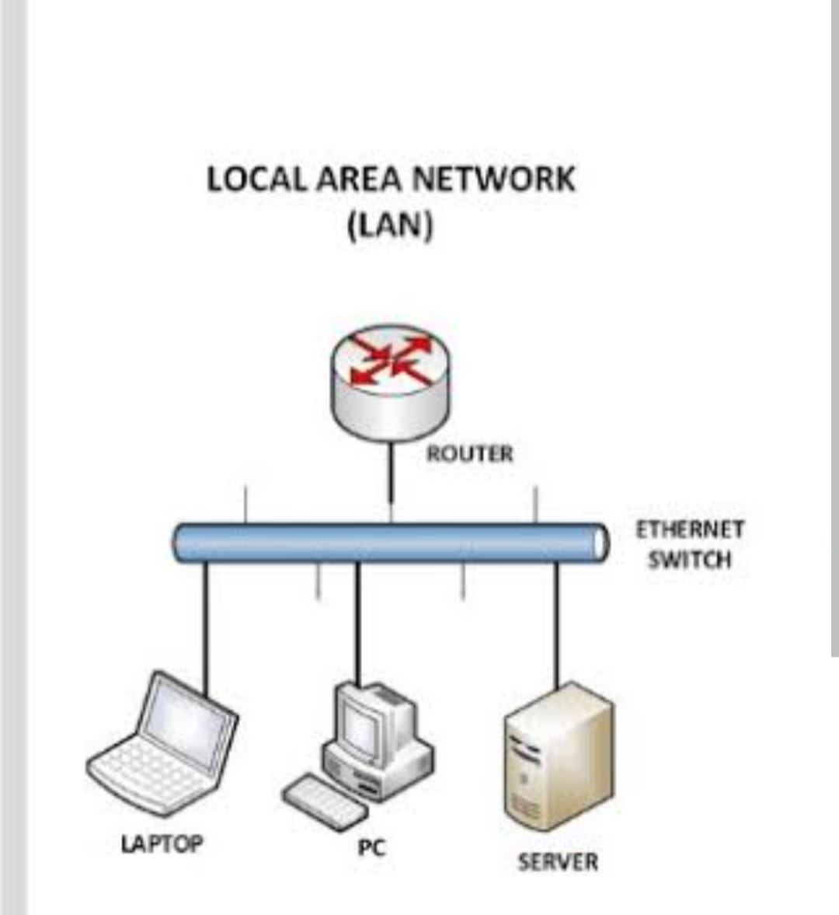

**Wide Area Network (WAN)**

WAN covers a larger area than LAN as well as MAN such as Country/Continent etc. WAN is expensive and should or might not be owned by one organization. PSTN or Satellite medium is used for wide area networks.   
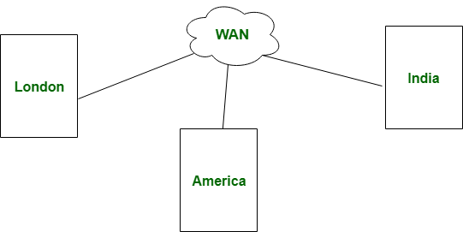

**Uses of WAN**

WAN is suitable when,

* An equipment or office is located in more than one geographical area.
* It is necessary to link several LANs for the organization of your data storage or use of common applications.
* In multinational organizations, there is always need of communication between different regional offices in the business.
* Levelling of reliance on external infrastructure like Internet or leased lines is still acceptable as a means of [telecommunication](https://www.geeksforgeeks.org/advantages-and-disadvantages-of-telecommunication/) for the long distances telecommunication.